Money and Politics:
The Relative Economic Power of the Corporate Community and Labor
Spencer Biddle, Drew Burchill, Odile Zuzu Irakiza

- Introduction.
G.William Domhoff’s book Who Rules America? analyzes the conflict of interests between a “corporate community” and a “liberal-labor alliance”, paying particular attention to the efforts of these actors to turn their economic power into political power. His analyses of “money and politics” focus on the role of political action committees (PACs) in the candidate selection process and of lobbying expenditures in the special-interest process. Domhoff argues that corporations have disproportionate economic influence and thus unmatched political power.
Drawing data from Open Secrets, www.opensecrets.org, we will show the drastic difference between the corporate community and liberal labor alliance, by comparing their PAC contributions,www.opensecrets.org/pacs/, and lobbying expenditures, www.opensecrets.org/lobby/. We will also take an in depth look at the Air Transport Sector through their actions with PACs, www.opensecrets.org/pacs/industry.php?txt=M01, and lobbying, www.opensecrets.org/lobby/indusclient.php?id=M01, to illustrate the economic disparity between corporations and labor unions.

2: PACs
Drew Burchill, Odile Zuzu Irakiza, Ryan Koster, Whit Merritt, Jordan Shattuck, Gabriel Trevor

In the United States, a Political Action Committee (PAC) is an organization that collects funds related to political campaigns, pools that money, and donates it to political campaigns. PACs can be for or against certain political candidates, ballot initiatives, or specific legislation. On the federal level, an organization becomes a PAC when it spends or receives at least one thousand dollars related to political activity. On the state level, this definition can vary.
According to the conventional wisdom, any group or individual has an equal opportunity to influence government through campaign contributions. In reality, however, corporations have the potential to spend much more money to influence political activities and political campaigns than labor unions could ever hope to. This is because in terms of the relative economic power of labor compared to corporations, corporations have significantly more economic resources at their disposal. This is demonstrated by the data found on opensecrets.org, a website that tracks specifically where money is spent to influence U.S. politics.
The data presented in the graphs below demonstrate that corporate spending is unmatched by that of Labor. The data compiled in Table 1 and Graph 1 show the total PAC contributions by both labor unions and industrial sectors in the 2012 election cycle. Labor unions contribute a significant amount of money to political campaigns — a total of $60,510,465 in the 2012 election cycle — but the contributions of labor are vastly overshadowed by the contributions of other industrial sectors. The only industrial sector that independently contributed more money than unions to campaigns in 2012 was the Finance, Insurance, and Real Estate sector, with

$71,332,506. Although few sectors independently contributed more money than the labor sector, the combined contributions of all industrial sectors of the corporate community dwarf those of labor. Together, the eight major sectors included in Graph 1 donated $266,565,311 to political campaigns in the 2012 election cycle—more than four times the contributions of labor, as demonstrated in Graph 2. ((Note that, in the context of (a) the conflict of interest between corporations and labor, and (b) the assertion that the members of the corporate community often cooperate in pursuit of their general interests (including anti-labor actions), it makes sense to compare the contributions of labor alone with the combined contributions of all corporate sectors)).
The campaign contributions of these industrial sectors represent the political interest of the corporate community. Graph 3 illustrates the vastly different patterns in campaign contributions between labor and the corporate community. All of the industrial sectors (excluding unions) donated more than half of their money to the Republican Party, and in certain sectors as much as 75% of contributions went to Republicans. The campaign contributions of the labor sector, on the other hand, represent the political interest of the workers. Reflecting the will of the majority, labor unions donate 90% of their campaign contributions to Democrats. Although the contributions of labor represent the majority interest, the other industrial sectors have much more money to donate, giving the corporate elites a disproportionate amount of political access.

Table 1: Total Campaign Contributions by Sector, 2012 Election Cycle
Sector | Total Contributions | % to Democrats
Agribusiness | $24,633,612 | 32
Communications/Electronics | $26,258,610 | 44
Construction | $14,756,489 | 28
Defense | $15,533,956 | 41
Energy & Natural Resources | $33,999,499 | 25
Finance, Insurance, & Real Estate | $71,332,506 | 37
Health | $57,003,500 | 43
Transportation | $23,047,139 | 33
Labor | $60,510,465 | 90

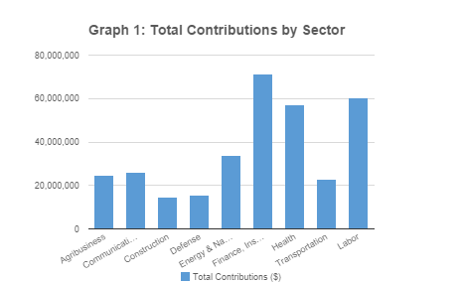

Table 2: PAC Contributions
Sector | Total Contributions
Labor | $60,510,465
Combined Corporate Sectors | $266,565,311

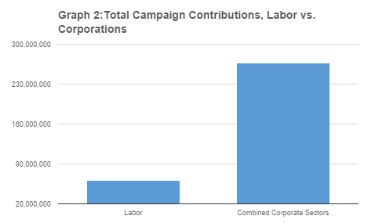

Table 3: Total PAC Contributions to Each Party by Sector
Sector | Total Contributions to Democrats | Total Contributions to Republicans
Labor | $61,100,000.00 | $6,166,384.00
Agribusiness | $20,900,256.00 | $61,200,500.00
Communications | $94,757,000.00 | $55,272,347.00
Construction | $25,326,834.00 | $63,843,923.00
Defense | $10,900,256.00 | $16,518,300.00
Energy | $22,674,400.00 | $92,316,456.00
Finance, insurance, real estate | $166,900,150.00 | $349,637,500.00
Health | $89,455,100.00 | $112,974,273.00
Misc Business | $123,000,000 | $186,971,245.00
Transportation | $17,546,300.00 | $54,177,300.00

Graph 3: Total PAC Contributions to Each Party by Sector
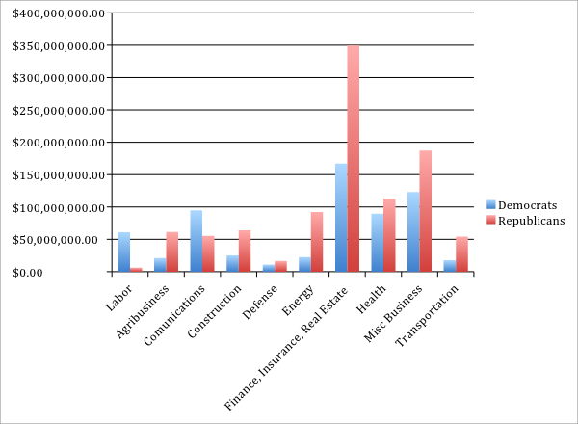

- Lobbying
Spencer Biddle, Charlotte Gyang-Duah, Daniel James, Charline Kirongozi, David Lawson
The corporate community researches ways to ensure that labor has little influence both in the government and on society. This is because unions provoke the government to implement laws that are beneficial to workers. Anything that is beneficial to workers is not beneficial to corporations. For this reason, labor is constantly attacked by corporations. According to Domhoff, two of the major players who organize programs to undermine the power of labor are the US Chamber of Commerce and the Business Roundtable. Using data, one would find that the lobbying expenditures of the corporate community exceed those of labor. Ultimately, this research will reveal the relative economic power of specific actors in the corporate community compared to labor. Labor Unions are completely dwarfed by the other sectors. In the top five sectors, the finance sector spent $488,997,892, the miscellaneous business sector spent $484,016,886, the health sector spent $483,917,302, the communication sector spent $393,424,474, and lastly the energy sector spent $357,934,635 on lobbying. When labor expenditure in lobbying, $46,912,680, is compared to these sectors, labor spends about three to four time less. Interestingly enough, when one looks closely at the miscellaneous business sector, one finds that Business Associations invest the largest amount of money in this sector. The major contributors among Business Associations are the U.S. Chamber of Commerce and the Business Roundtable. When these two groups are combined, they contribute $86, 860,000 which is about two times the amount the labor sector spends on lobbying. The U.S. Chamber of Commerce alone spends almost two times more than the labor sector with $74,470,000. With the amount of money that these corporate groups are spending on lobbying, they are able to gain more access to the government in pursuit of their special interests. Domhoff, in Who Rules America?, introduced these two groups as the major participants when it comes to helping the corporate community transfer their economic power into political power. Based on the amount of money spent on lobbying, Domhoff’s analysis is correct. Examining lobbying expenditure closely shows that “particularistic” nature of the American political support system; anyone can support whomever they choose, but only few can afford to make a difference. From the data that were given about lobbies, big corporations do have a network that tries to manipulate government policy. Corporations therefore succeeded in turning their economic power into political power because even though unions are supported by the majority, they still do not have access to the government due to the fact that they have less wealth than corporations.

Table 1: Lobbying in Labor Sector v. Top 5 Sectors in 2013
Sectors | Total Amount($)
Labor/Union | $46,912,680
Finance/Insurance/Real Estate | $488,997,892
Miscellaneous Business | $483,917,302
Health | $483,917,302
Communication/Electronics | $393,424,474
Energy/Natural Resources | $357,934,635
Graph 1: Lobbying in Labor Sector v. Top 5 Sectors in 2013

 | Table 2: Labor v. Business Associations in 2013
 | Sectors | Total Amount($)
 | Labor/Union | $46,912,680
 | US Chamber of Commerce | $74,470,000
 | Business Roundtable | $12,390,000
 | Graph 2. Labor v. Business Associations in 2013
 | Graph 2: Labor v. Business Associations in 2013

4. Case Study: The Air Transport Sector

Anthony Jreije, Bianca Little, Teide Riley-McNary, Markus Stein, Kristi Xhelili

The Air Sector Industry is an extensive and important industry in America full of people, unions, and money. It consists of many significant “players” such as UPS, and FedEx, which are easily recognizable trademarks. These companies also have a large impact on how other business are able to function due to the transportation industry being vital to other industries. This sector has interest in government policies because of its vast impact on the country as a whole. Therefore, it has the power to suppress the efforts of unions to oppose them in the political process. As such, this business sector lends itself to a thorough analysis of how relative economic power is converted to influence in the political arena.
Observing Figure 1, it is apparent that a nearly staggering forty million dollars were spent by corporations on lobbying efforts. This figure vastly dwarfs the amount of money available to unions in the Air Transport industry. The data concludes that unions are only able to come up with roughly a twentieth of what corporations and businesses are able to come up with. In fact, the single company of FedEx is able to raise more money than all of the Air Transport Unions put together.
This significant inequality shows the massive advantage that large corporations have over the unions regarding political access and influence. With a rough amount of $4 million, the unions altogether are able to hire 74 lobbyists. On the contrary, corporations are able to hire 645 lobbyists with their funds (OpenSecrets). The lobbyists hired by corporations are also the best ones money can buy. Therefore, these corporations don’t have the advantage in only quantity, but in quality as well. This substantial advantage allows the voice of the corporate community to overpower the voice of the unions. In other words, the small corporate community gets vastly more say, influence, and representation in the political process rather than the larger community of less wealthy people.
Figure 2 shows PAC donations in the air transportation industry. The most important difference to look at is the sheer difference between the donations from corporations and the donations from unions. Despite the fact that unions represent a much larger number of people, the corporate total donation is roughly twice – 2.01 – than that of the union donation. The number one corporate donation from the corporate community comes from UPS which poured almost two million dollars into the political system. Fedex and airline companies followed close behind, but one clear pattern is their preference for Republican candidates. For most of these companies, the Republican donation was more than double the Democrat donation. The unions, on the other hand, showed preference for the Democrats.
The reason for these patterns comes from the value large corporations can get out of supporting politicians who support their business practices. The big businesses that were the major donors for the Air Transportation industry all have a major stake in politics because legislation such as environmental regulation has the potential to be extremely detrimental to their profit margin. As such, these corporations find it worthwhile to take from their profits, extremely large sums, in order to help candidates that will not support regulatory legislation that could potentially hurt these companies. The unions, on the other hand, try to support the Democratic candidates in hopes of earning benefits for the working class generally supported by Democratic candidates. However, the money that large companies can afford to donate is vastly more than the amount that can be gathered by unions. Unionized workers typically cannot afford to donate all that much from their personal wealth when compared to the massive wealth generated by these large nationwide companies.
This inability for the large number of people that are relying on unions for representation to keep up with the massive amount of money that large corporations can pour into the political system allows the corporate rich to have a much greater voice in a supposedly equitable political arena. Despite the idea that each person has an equal voice in government, large amounts of money appears to allow the corporate community to be far over-represented in terms of access to the government.

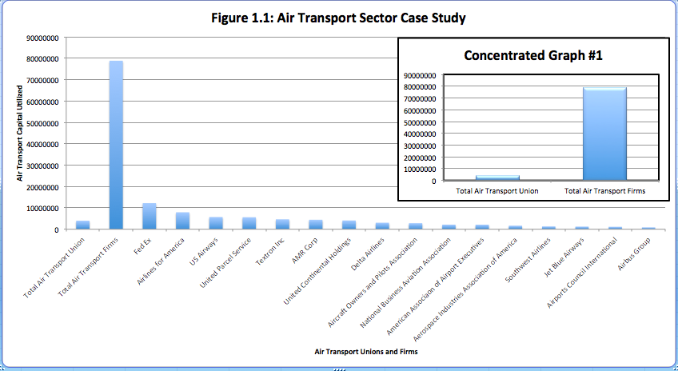

Figure 1.2: Air Transport Sector Case Study

Sectors | Lobbying Expenditures
Total Air Transport Union | 3,996,157
Total Air Transport Firms | 78,828,483
Fed Ex | 12,200,912
Airlines for America | 7,920,000
US Airways | 5,707,000
United Parcel Service | 5,601,793
Textron Inc | 4,630,000
AMR Corp | 4,430,000
United Continental Holdings | 4,090,118
Delta Airlines | 3,040,622
Aircraft Owners and Pilots Association | 2,830,000
National Business Aviation Association | 2,140,000
American Association of Airport Executives | 2,118,354
Aerospace Industries Association of America | 1,660,000
Southwest Airlines | 1,300,000
Jet Blue Airways | 1,220,000
Airports Council International | 1,135,000
Airbus Group | 880,000
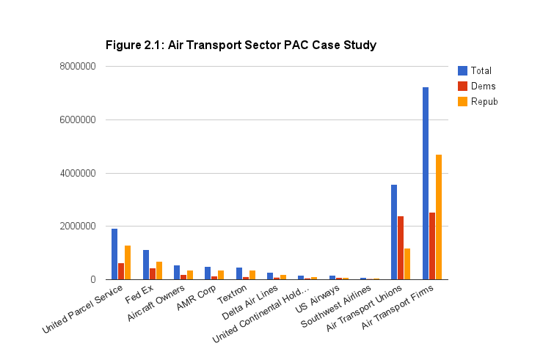

Figure 2.2 Air Transport Sector PAC Case Study
PACs | Total | Democrats | Republicans
United Parcel Service | 1,920,590 | 634,869 | 1,285,721
Fed Ex | 1,123,000 | 432,500 | 690,500
Aircraft Owners | 549,000 | 202,000 | 347,000
AMR Corp | 501,100 | 141,100 | 360,000
Textron | 468,500 | 123,500 | 345,000
Delta Air Lines | 279,999 | 96,000 | 183,999
United Continental Holdings | 164,750 | 60,750 | 104,000
US Airways | 156,000 | 75,000 | 80,000
Southwest Airlines | 85,900 | 31,500 | 54,400
Air Transport Unions | 3,582920 | 2,395,920 | 1,179,500
Air Transport Firms | 6,175,972 | 2,130,621 | 4,045,351

