Subsidizing the Free Market(eers)
Marie Deininger
Nikki Feinberg
Sasha Patsel

Charles Koch has written several op-eds in recent years that criticize government intervention in the market in general, and subsidies in particular. He writes, for example: “I have spent decades opposing cronyism and all political favors, including mandates, subsidies and protective tariffs—even when we benefit from them. I believe cronyism is nothing more than welfare for the rich and powerful, and should be abolished.” (Koch, Charles. "I'm Fighting to Restore a Free Society." Wall Street Journal [New York, NY] 13 Jan. 2015: Print.)
His critique of government/subsidies is not surprising, given his free-market ideology. He is well known to support this ideology via his foundations' funding of free market think tanks and policy discussion groups. The liberal/environmental media was quick to point out Koch's “hypocrisy”, presenting data on his acceptance of substantial subsidies and his lobbying to maintain outdated, but lucrative, oil and gas subsidies:
Charles and David Koch, the secretive billionaire brothers who own Koch Industries, the largest private oil company in America, have spent millions bankrolling free-market think tanks and pro-business politicians in order, as David Koch has put it, “to minimize the role of government, to maximize the role of private economy and to maximize personal freedoms.” But a closer look at their dealings reveals that for the past 35 years the brothers have never shied away from using government subsidies to maximize their own profits, even while endeavoring to limit government spending on anything else. Simply put: the Kochs have no problem with socialism--as long as they’re in on the action. (Levine, Yasha. "7 Ways the Koch Bros. Benefit from Corporate Welfare." The Exiled (2010): Web.)

We wonder how common this sort of "contradiction" might be among those members of the corporate community that are heavily involved in the policy planning arena. According to Domhoff, “The corporate rich supplement their small numbers by financing and directing a wide variety of nonprofit organizations, such as tax-free foundations, think tanks, and policy-discussion groups, to aid them in developing policy alternatives that serve their interests” (Who Rules America, P. xii). To determine whether or not this contradictory behavior is unique to the Kochs, or is a more patterned corporate behavior (that is, to see if the corporate rich do or do not fund a "free market policy" planning network while simultaneously accepting government subsidies), we will do the following: 1. develop a list of free market think tanks; 2. identify their foundation funders; 3. link these foundations to their corporate funders; 4. track the subsidy histories of these corporations.
In order to test our hypothesis that this pattern isn’t unique to Koch Industries we identified conservative think tanks advocating for a free market ideology. Starting with conservative transparency’s (www.conservativetransparency.org) list of conservative think tanks, we searched each think tank’s online mission statements for any combination of the following terms: “free market,” “limited government,” “free enterprise,” “laissez-faire”. We considered these to be “free market think tanks”. Using conservative transparency again, we were able to identify connections between foundations and think tanks by creating a list of all foundations that funded free market think tanks in recent years. See Tables 1 and 2 for our “raw data” on the connections and money flows between foundations and think tanks, and for lists of the abbreviations used in subsequent graphs and charts. From this list we produced a shorter list of the most active foundations (i.e., those with the most connections and/or those that gave large sums of money). We created a spreadsheet of the money flows between these foundations and our free market think tanks in 2012 (a presidential election year). These connections demonstrate the existence of a dense NETWORK of interacting organizations (see below).

Table 1: Think Tanks – Connections with and Money Received from Foundations
Think Tanks | Abbreviations | Number of Connections | Money Received
Atlas Economic Research Foundation | ATLAS | 13 | $961,606
Cato Institute | CATO | 13 | $656,345
Competitive Enterprise Institute | CEI | 12 | $2,260,900
Institute for Justice | IJUST | 12 | $2,145,200
Foundation for American Studies | FAS | 12 | $40,000
Manhattan Institute for Policy Research | MANHAT | 11 | $1,170,250
Pacific Research Institute for Public Policy | PRIPP | 11 | $818,174
Reason Foundation | RF | 10 | $2,462,815
Fund for American Studies | FundAS | 10 | $504,549
Philanthropy Roundtable | PR | 10 | $471,377
Hundson Institute | HUDSON | 9 | $5,405,000
American Enterprise Institute | AEI | 9 | $3,201,539
Acton Institute | ACTON | 9 | $16,000
State Policy Network | SPN | 8 | $3,973,988
Capital Research Center | CRC | 7 | $447,000
National Center for Policy Analysis | NCPA | 7 | $403,174
Freedomworks | FW | 7 | $15,000
Heartland Institute | HEARTLAND | 6 | $1,182,500
Pacific Legal Foundation | PACIFIC | 6 | $325,000
Heritage Foundation | HERITAGE | 5 | $1,858,774
Texas Public Policy Foundation | TPPF | 5 | $263,000
Property and Envrionment Research Center | PERC | 4 | $504,000
The Freedom Foundation | FF | 4 | $313,500
Washington Legal Foundation | WLF | 4 | $56,000
Ayn Rand Institute | RAND | 3 | $422,000
Fraser Institute | FRASER | 2 | $232,000
Academy on Capitalism and Limited Governemnet Foundation | ACLGF | 2 | $25,000

Table 2: Foundations – Connections with and Money Donated to Think Tanks
Foundations | Abbreviations | Number of Connections | Total $ Donated to Free Market TT
Donors Capital | DC | 23 | $9,074,779
Lynde and Harry Bradley Foundation | BRADLEY | 22 | $2,931,000
Koch Foundations | KOCH | 20 | $942,157
Armstrong Foundation | ARMSTRONG | 20 | $323,500
Donors Trust | DT | 19 | $3,459,533
Searle Freedom Trust | SEARLE | 19 | $3,894,500
Sarah Scaife Foundation | SCAIFE | 17 | $2,812,500
Rodney Fund | RODNEY | 14 | $165,062
Earhart Foundation | EARHEART | 12 | $437,500
Roe Foundation | RF | 12 | 201,500
John William Pope Foundation | POPE | 11 | $435,000
F.M. Kirby Foundation | KIRBY | 10 | $442,500
Chase Foundation of Virginia | CHASE | 9 | $325,000
Aequus Institute | AQUUES | 8 | $84,500
Lowndes Foundation | LOWNDES | 7 | $205,000
Claws Foundation | CLAWS | 4 | $1,250,000

Using standard online search tools, we managed to identify seven corporations connected to the foundations in this network. For the purpose of this study, we will be analyzing the donations made to think tanks by foundations and identifying which corporations are in turn funding those foundations. Next, we identified which of these corporations received government subsidies - money that directly conflicted with their free market ideologies – by using Good Jobs First’s “subsidy tracker”. According to its website “Subsidy Tracker 3.0 is the first national search engine for economic development subsidies and other forms of government financial assistance to business” (“Subsidy Tracker 3.0.” Goodjobsfirst.org.).
Graph 1 below shows the free market think tanks we analyzed and how many connections they have to our short list of foundations. In addition, the graph shows the total amount of money each think tank received from various foundations.
Graph 1:
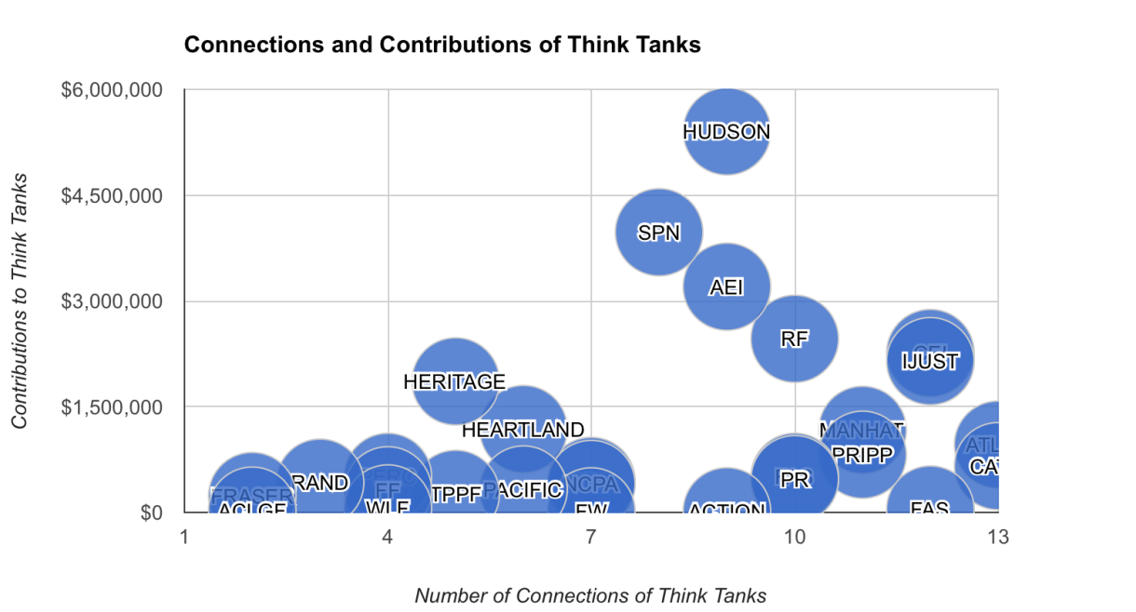
As demonstrated in Graph 1, the maximum amount of connections any think tank had with foundations was 13 (Atlas Economic Research Foundation and Cato Institute). While Hudson Institute was less connected, it received the greatest total sum of contributions ($5,405,000). The point remains though, that an intricate and highly connected network of conservative think tanks and foundations support each other and serve each other’s interests. It is important to specify some of the activities of these think tanks. The Hudson Institute does conservatively-focused research on many public policies, including national defense, education, crime, immigration, pesticides, and international issues. The Cato Institute and the Atlas Research Foundation are tied to a wide range of public policy issues informed by libertarian principles. All three of these think tanks are either founded by and/or funded by the Koch brothers.
Once we examined the think tanks in our research, we took a closer look at the foundations that fund them. This analysis is reflected in the graphs below. Graph 2 plots the total amount of money a given foundation disbursed to the specified free market think tanks against its total amount of connections to various think tanks.
Graph 2:
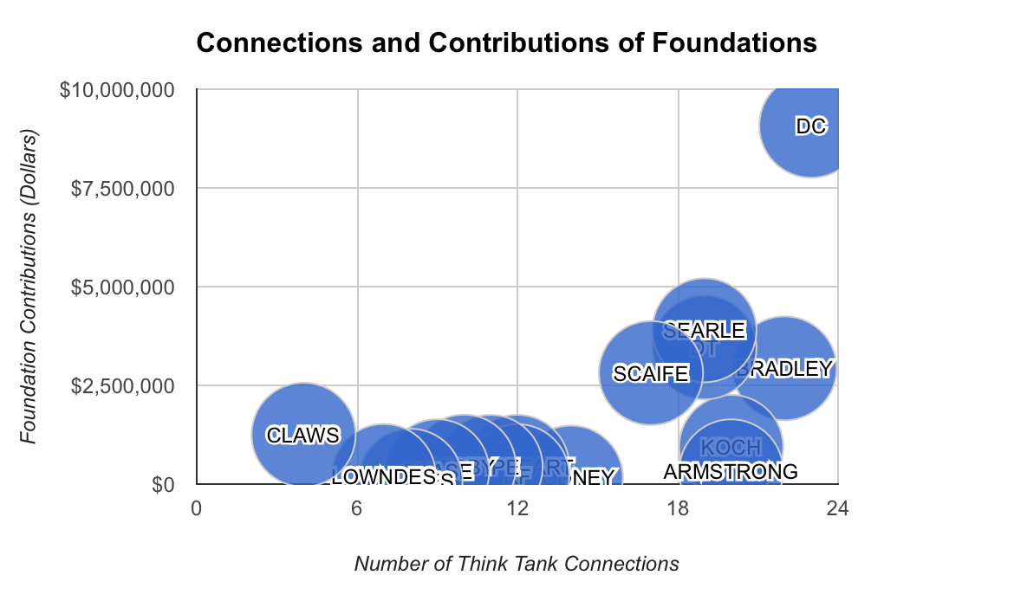
Graph 2 details an intricate network of foundations and think tanks, this time from the foundation side. Of the foundations we identified, Donors Capital was by far the most active. They were the leaders in both total money contributed ($9,074,779) as well total amount of connections (23). Note that this pattern is even more pronounced when we consider Donors Trust in conjunction with Donors Capital (the two share headquarters and staff, and are considered “sister organizations”). Donors Trust spent $3,459,533 and had 17 connections. The relative activity of these foundations is perhaps even better depicted in the pie charts below.
Graph 3:
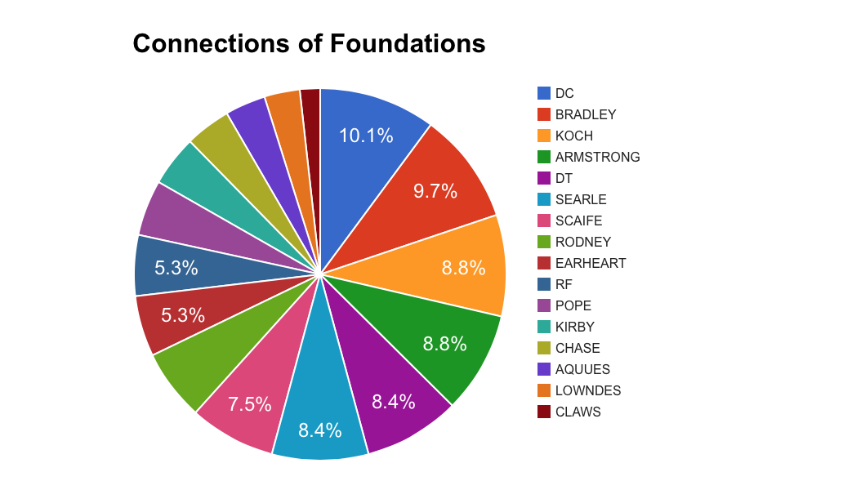

Graph 4:
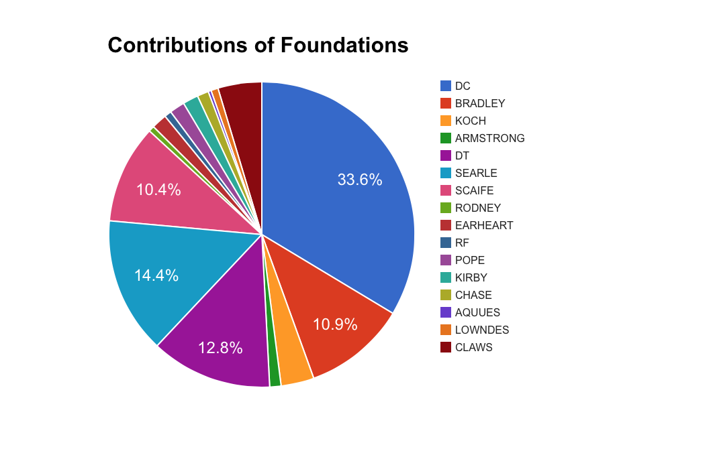
Once we established this network, our next step was to track the sources of the money donated. In other words, our objective was to link our foundations to their known corporate sponsors. The most prominent foundations include the Koch Foundations, the Scaife Foundations, Pope Foundation, Searle Freedom Trust, ExxonMobil, and the Lynde and Harry Bradley Foundation. It is important to note that the Scaife Foundations are connected to many corporations because the Scaife family has large investments in Chevron, Alcoa, Westinghouse and General Motors (among others). The other major foundations (Koch, Searle, Bradley, and Pope) are connected to just one parent corporation each.
The final segment of our research is the part that finally underlines the “contradictions” noted above. The following table shows the amount of government subsidies accepted by the corporations that we found to be connected to our foundations. As evidenced by Table 3, Alcoa and General Motors received the greatest amount of money, followed by Pfizer, Koch Industries, Chevron, Rockwell International, and Westinghouse.
Table 3: Subsidies Accepted by Corporations that Advocate Free Markets
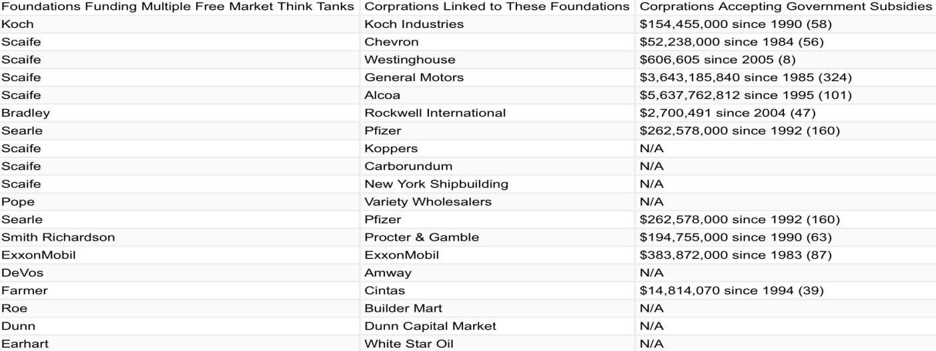

We initially asked if Charles Koch was hypocritical in criticizing the disbursement of government subsidies while simultaneously accepting them. By revealing the amount of money accepted as subsidies by the corporations linked to the top foundations that fund free market think tanks, we in turn show that these foundations, and consequently the think tanks they sponsor, indirectly accept a significant amount of government money for their own benefit. It is hypocritical because the very purpose of these think tanks--who are also the eventual beneficiaries of the corporate money--is to criticize subsidies while their very existence is at least partly a result of them. Charles Koch is not alone. Often other free marketeers accept large amounts in subsidies.

References

"Conservative Transparency." ConservativeTransparency.org Web.

Domhoff, G. William. (2014). Who Rules America?: The Triumph of the Corporate Rich
(Seventh ed.). McGraw Hill.

Koch, Charles G. "Charles Koch: I'm Fighting to Restore a Free Society." Wall Street Journal
[New York, NY] 2 Apr. 2014: Print.

Levine, Yasha. "7 Ways the Koch Bros. Benefit from Corporate Welfare." The Exiled (2010):
Web.

“Open Secrets.” OpenSecrets.org Web.

“Source Watch.” SourceWatch.org Web.

"Subsidy Tracker 3.0." GoodJobsFirst.org Web.

Koch Industries, Chevron, Westinghouse, General Motors, Alcoa, Rockwell International, and Pfizer

