Money and Politics II: Outside Spending and the Relative Economic Power of Conservatives/Industries vs. Liberals/Labor, 2004-2014

Lead Authors: Katy Deng, Paul Frissora, Vu Pham, and Sarah Shine
Contributing Authors: Shara Baptiste, Frenk Caushi, Joseph Costner, Erica Feigin, Miguel Garcia, Bill Holloman, Nate Keuter, Sam Luz, Derek Michaud,Chris Najimy, Cass Napolitano, Davit Tvildiani, and Ben Zieff

Statement of the Problem
In the book Who Rules America?, G. William Domhoff analyzed the conflict of political interests between the corporate community and the liberal-labor alliance. One of the many aspects analyzed is the difference in economic strength between the two groups. The corporate community is more capable of converting its vast economic power into political power. A group of students from last year’s Sociology 033 class wrote about “money and politics”, focusing on the role of political action committees (PACS) and lobbying expenditures. Their findings supported Domhoff’s argument that there is an unequal distribution of economic power between the corporate community and labor.
One topic that last year’s students neglected was the 2010 Citizens United vs Federal Elections Commission case. The Supreme Court decision in 2010 had an enormous impact on money and politics in American society. Domhoff states on the decision: “The escalation in corporate-related funding reached heights that would not have been believed possible early in 2010. A 5-4 majority of the Supreme Court ruled in Citizens United v. Federal Elections Commission to uphold a challenge to legal restrictions on donations from corporate funds for ‘independent expenditures’ as a violation of the free speech rights granted to all persons by the First Amendment”. The Supreme Court made two major rulings: 1) to challenge the restriction of donations from corporations and unions as a violation of the free speech rights and 2) to the challenge the ruling by the Court of Appeal that PACs that did not give to parties or candidates could collect as many funds as they like from corporations and unions. Domhoff examines the individuals in the Supreme Court: “The Supreme court has reflected the range of acceptable opinion within the corporate community on the issues of concern to it. The appointees were also primarily from the upper- and upper-middle classes, and an ‘inordinate number had served as corporate attorneys before their appointments’. In addition, they also tended to be from elite law schools, to have abandoned the practice of corporate law for lower-level judicial appointments or professorships at prestigious law schools, and to have been active in a political party”. In other words, the Supreme Court is decidedly “pro-corporate”.
In addition, last year’s focus on PACs and lobbying failed to examine another important type of money in politics: outside spending. Therefore, we will use data made available by Open Secrets (www.opensecrets.org/outsidespending/ ) on the outside spending activities of conservatives and liberals, both prior to the Citizens United decision (pre-CU) and after that decision (post-CU). Actually, Open Secrets aggregates the outside spending data in three different ways: by group viewpoint (conservative vs. liberal spending), by donor industries (industries vs. labor spending), and by dark money groups. Consequently, our research will be conducted in three phases corresponding to these topics. Outside spending is defined by OpenSecrets.org as “political expenditures made by groups or individuals independently of, and not coordinated with, candidates' committees”. Such expenditures included electioneering communications, advertising, and other types of independent expenditures.

PHASE 1: Outside Spending: Liberals vs. Conservatives
Data/Methods
Data were collected for the purpose of analyzing outside spending by conservatives and liberals by election cycle, 2004-2014. The data on “group viewpoint” are found here: https://www.opensecrets.org/ https://www.opensecrets.org/outsidespending/summ.php?disp=O. In order to do this, students were divided up into groups and looked at a specific type of outside spending. There were six election cycles and seven types of spending: electioneering communications, single-candidate groups, Super PACs, non-party committees, non-disclosing groups, single-candidate Super PACs, and independent expenditures. From there, each group was responsible for making a graph of one of the seven types with all six election cycles included. The last group was responsible for making a graph that included all types of spending combining the results from all the other seven groups. All the graphs display two separate bars (red for conservative and blue for liberal) for each election cycle for the purpose of comparison. However, this paper will focus on just one graph that includes all types of spending and four additional graphs that summarize the findings.
Findings
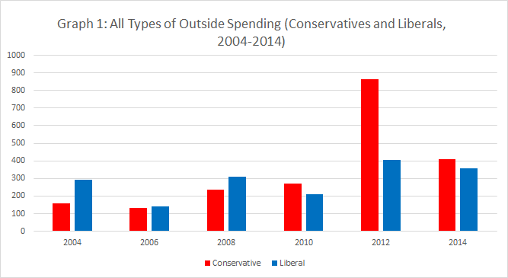
Graph 1 shows conservative and liberal outside spending totals for each election cycle from 2004 to 2014. Prior to the CU decision (2004-2008), spending levels were low and liberals outspent conservatives. A reversal took place from 2010 on: spending levels increased and conservatives outspent liberals. Additional noteworthy patterns of money flow can be seen by looking at the years in which general elections took place—2004, 2008, and 2012. In the 2012 election cycle, conservatives spent 861.8 million dollars, which is more than double the amount liberal groups spent in that cycle and almost four times as much as conservative groups had spent in the previous general election cycle of 2008, and almost 6 times as much as 2004. Clearly, the CU decision opened the floodgates to conservative outside spending. 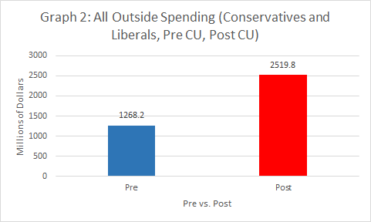
Graph 2 shows outside spending by both liberals and conservatives combined, pre- and post-CU. After the ruling, outside spending nearly doubles, going from $1,268,200,000 to $2,519,800,000. This is because the Citizens United ruling greatly reduced the amount of restrictions and regulations that had previously been in place in regards to corporate and labor spending. One of the justifications given for Citizens United was that it would impact liberal groups just as much as it would impact conservative groups. Unions, which usually lean left, would now be allowed to freely spend just as much as conservative groups, according to conservative pundits. We can assess this “justification” by simply analyzing the ratios of conservative and liberal spending before and after the Citizens United ruling.

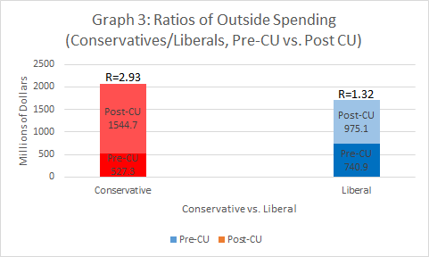
The findings of Graph 3 show that conservative spending increased nearly threefold post-CU; with the exact ratio of pre and post spending being 2.93. This is contrasted by spending by liberals, which only increased by 1.32 times after the decision. This shows that the event of Citizens United benefitted conservatives disproportionately. Their superior economic power now enables them to outspend liberals by a wide margin.
Next, we can look at the bar graph for outside spending pre and post Citizens United, this time divided by outside spending by liberals and conservatives.

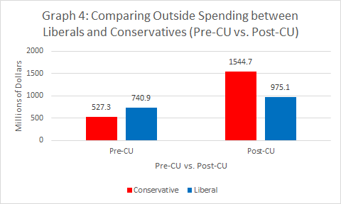
Graph 4 shows again that, before Citizens United, the outside spending of liberals is higher than conservatives. After that, however, conservative spending far outpaces that of liberals.
The Table below presents post-CU spending totals of conservatives and liberals broken down by specific types of spending (see above). It also includes C/L ratios for each type of spending. These ratios always exceed 1.0, meaning that, for every single type of outside spending, conservatives have a spending advantage. An interesting point to note is that the highest ratios (greater than 6) were for electioneering communication (primarily advertising) and non-disclosing groups (“social welfare” organizations that do not have to disclose their donors), but that the amount of money spent on the latter far exceeded spending on the former. This seems to indicate that, after CU, conservatives took particular advantage of the ability to spend anonymously (so-called “dark money” expenditures – see below).

Table: Ratios of Outside Spending Between Liberals and Conservatives Post Citizens United by Type of Spending
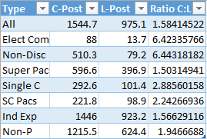
Conclusion
The purpose of this project was to expand on Domhoff’s analysis of money in politics. Last year’s students explored the relative economic power of the corporate community (conservatives) and liberal-labor alliance (liberals) based on PACs and lobbying expenditures but did not include outside spending. Their data supported the fact that the corporate community does in fact spend more than the liberal-labor alliance, but only enough to assert that claim for PACs and lobbying expenditures. An examination of outside spending was needed to further assess Domhoff’s assertion that the corporate community contributes more than the liberals in support for elections. Last year’s students also left out the crucial turning point in their analysis, which was the 2010 Citizens United v. Federal Elections case. The Supreme Court made a decision that favored the corporate community granting the right to spend unlimited amounts of money in the form of “expenditures”. The data presented in this paper clearly show that in the years before the Citizens United decision, the limits placed on spending are reflected in the contributions made by conservatives and liberals. Conservatives spent a little less than liberals. However, the years after Citizens United show a huge rise in outside spending from the conservatives. A rise in spending for liberals also occurred but not as much as the conservatives. The evidence supports Domhoff’s assertion: the corporate community (conservatives) has far more economic power than liberals
Phase 2: Labor Vs. Industries in Outside Spending
The previous phase of the project examined outside spending by conservatives and liberals. However, OpenSecrets.org also provides outside spending data specifically aggregated by labor unions and industries. While the conservative-liberal and industry-union categories are similar, there is some value to examining specific data on the latter dichotomy, especially given Domhoff’s emphasis on the anti-union policy priorities of the corporate community and the attendant conflict of interests between conservative industries and labor.
Data/Methods
Data were collected for the purpose of analyzing outside spending by labor unions and industries. In order to do this, students were divided up into groups and looked at six election cycles, summing up the total amounts of money (in millions) for labor unions and the totals for selected (i.e., conservatively-oriented) industries. The industries included were: transportation, miscellaneous business, finance/insurance/real estate, energy/natural resources, defense, construction, communication/electronics, and agribusiness. Each student group added up the total amount of spending by these industries and compared that to the amount spent by labor unions, incorporating this information into bar graphs for each election cycle. Based on the bar graphs, a summary table was constructed that included the total amounts spent by (a) labor unions and (b) all industries combined, as well as (c) industry/labor ratios for each election cycle. Then, using the summary data in the table, we made five graphs that depict the outside spending patterns of labor unions and industries.

Findings
TABLE 1: Outside Spending (In Millions) by Industries (I) and Labor (L), 2004-2014

 | Labor | Industries | I/L Ratio
2004 | 8.1 | 90.6 | 11.2
2006 | 2.1 | 13.63 | 6.49
2008 | 21.5 | 8.6 | .4
2010 | 27.7 | 49.14 | 1.77
2012 | 115.7 | 582.08 | 5.03
2014 | 113 | 299.05 | 2.05

The table above summarizes outside spending (in millions) by industries and labor unions
from 2004-2014. The industry/labor ratios all show that, with one exception, industries outspent labor unions by a wide margin. The only exception to this would be seen in the 2008 election year, where the industries-to-labor ratio (8.6/21.5) was .4. Apparently, labor made a special effort to support the Obama campaign. 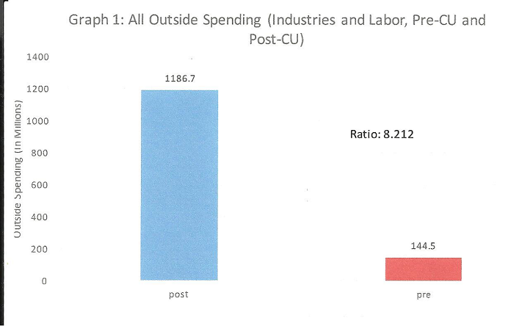

Graph 1 compares all outside spending for both industries and labor unions pre and post Citizens United. The ratio of post/pre CU (1186.7/144.5) is 8.212, meaning that outside spending increased eight fold after the year 2010. This was the post-Citizens United era, documenting with precision the opened floodgates to huge outside spending increases after the Citizens United case.
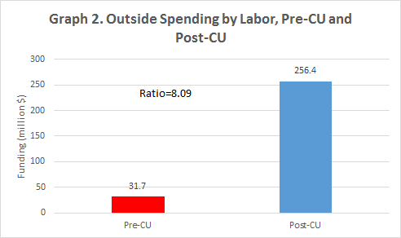
Graph 2 compares outside spending by just labor unions pre and post Citizens United. The ratio of post/pre (256.4/31.7) is 8.09, meaning that labor outside spending increased eight fold after the Citizens United case.
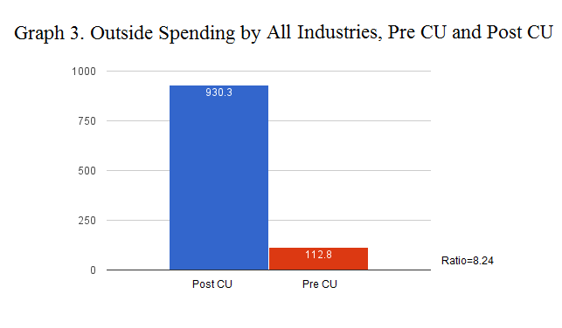
Graph 3 compares outside spending by all industries pre and post Citizens United. The ratio of post/pre (930.3/112.8) is 8.24, meaning that industry outside spending once again increased eight fold after the Citizens United case.
Graph 4. Comparing the Outside Spending of Labor (L) and Industries (I), Pre CU
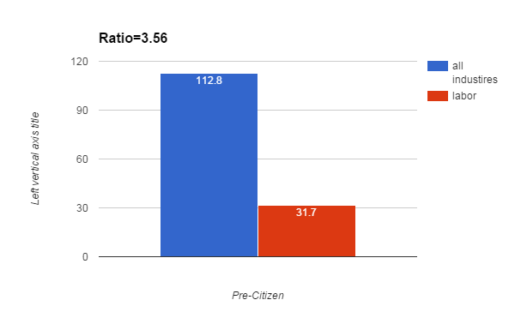
Graph 4 compares the the outside spending of labor and industries pre-Citizens United. The ratio of industries to labor (112.8/31.7) is 3.56, meaning that industries outspent labor unions by almost four times even before the crucial Citizens United turning point.
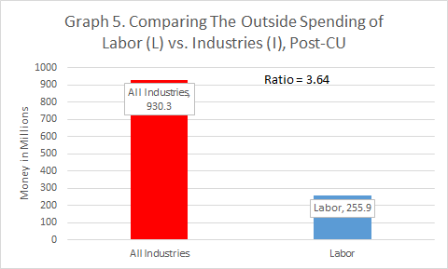

Graph 5 compares the outside spending of labor and industries post- Citizens United. The ratio of industries to labor (930.3/255.9) is 3.64, meaning that industries once again outspent labor unions by almost four times after the Citizens United case. After Citizens United, industries far outspent labor unions in all three election cycles, providing evidence for their economic power.
Conclusion
The purpose of phase 2 of this project was to analyze outside spending made specifically by labor unions and industries. From the findings, it is clear that Citizens United permitted both industries and labor unions to increase their spending, as total outside spending overall increased by eight fold after 2010. However, when comparing labor unions to industries, it is even more evident that industries have far more to spend than labor unions because they far outspent unions by more than three fold, both pre and post Citizens United.

Phase 3: Dark Money Flows
In addition to examining outside spending by (a) conservatives vs. liberals, and (b) industries vs. unions, we can also study the flow of “dark money” into political campaigns. Dark money is defined as campaign donations that go to politically-active non-profit organizations. Dark money, however, is not easily traceable. Post-Citizens United, politically-active non-profits are allowed to receive unlimited corporate, labor, or individual donations, and furthermore, are not required to disclose the names of donor organizations. In order to receive tax advantages, however, the donor organizations must disclose their donations on their tax forms. Opensecrets presents data on some of the top donors to dark money groups. They sifted through thousands of IRS990 tax forms (where the donor disclosure occurs) to produce their list of top donors (see the Table below). While the list of donors is fairly long, and the dark money flows discovered are substantial, it is important to note that many of the sources/donors to politically-active nonprofits, as well as much of the money flowing to politically-active nonprofits, remain unknown.

Shown in the table below is detailed information regarding the spending patterns of the top several dozen dark money groups by how much they donate to politically-active nonprofits. The first column in this table lists the full name of the donor organization. The second column details how much money they gave to conservative recipients, and the third details how much money went to liberal recipients. The fourth and final column states whether or not the organization is linked to the Koch Network. The Koch brothers are two ultra-conservative industrialist billionaires who together spend millions of dollars during election cycles through their various Super PACS, Think Tanks, and Dark Money groups. Their umbrella-like control over a range of conservative organizations can be seen through this sociogram (from last year’s class):
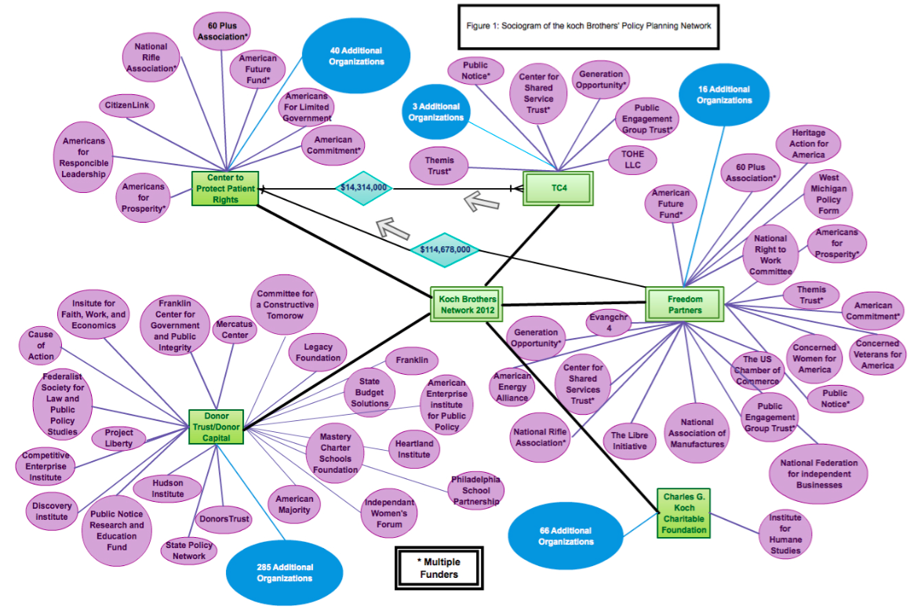
In one final element to the table, many cells are shaded in green. This indicates that the group focused its expenditures on environmental nonprofits. This comes almost exclusively from liberal dark money groups, as conservatives are far less likely to look positively on environmental regulations. This table shows some key patterns. Liberal dark money groups have spent $240,306,684 from 2008 to 2014. This seemingly large number is dwarfed by the total conservative spending in the same timeframe: $701,204,682. Furthermore, of the total conservative money spent, $589,997,104 was linked to the Koch network, more than 84% of the total conservative spending by dark money groups. Meanwhile, of the $240,306,684 spent by liberal dark money groups, $180,689,894 was spent on environmental organizations, coming to around 75% of the liberal money spent during that period. With the total money from dark money groups reaching almost a billion dollars, it is beyond doubt that the flow of this amount of money into politics has an impact.
Based on this information, it is appropriate to conclude that dark money groups in America, on both sides of the political spectrum, hold substantial amounts of economic power in regards to American politics. Not only are dark money groups able to donate unlimited amounts of money for political expenditures, but their recipients are not required to disclose who gives them money. By spending far more than liberals, conservatives (members of the corporate community) take great advantage of the post-Citizens United rulings. (See the table below.)

Dark Money Groups by (a) Ideology, (b) Koch Network Ties,and c) Liberal Environmental Interests, 2008-2014 |  | *Green=environmental spending
Name of Organization | Conservative Money | Liberal Money | Koch Links
Freedom Partners Chamber of Commerce | 243,049,000 |  | Y
Center to Protect Patient Rights | 169,119,455 |  | Y
Sea Change Foundation | 0.00 | 62,219,482 | N
ClimateWorks | 0.00 | 51,500,001 | N
Crossroads GPS | 50,675,000 |  | N
TC4 Trust | 45,536,800 |  | Y
Atlantic Advocacy Fund | 0.00 | 42,692,000 | N
Americans for Job Security | 24,645,750 |  | Y
Advocacy Fund | 0.00 | 24,307,616 | N
Wellspring Cmte | 16,463,552 |  | Y
Green Tech Action Fund | 0.00 | 15,179,988 | N
Donors Trust | 14,133,103.00 |  | Y
Pharmaceutical Research and Manufactureres of America | 13,780,000.00 |  | Y
American Action Network | 13,135,000.00 |  | Y
Cellular Telecom and Internal Association | 12,278,567.00 |  | N
Republican Jewish Coalition | 8,000,000.00 |  | Y
American Future Fund | 7,403,700 |  | Y
Environment America | 0.00 | 7,147,955 | N
National Christian Charitable Foundation | 5,202,431 |  | N
Partnership Action Fund | 0.00 | 5,158,814 | N
Free Enterprise America | 5,057,000.00 |  | No
Wisconsin Club for Growth | 4,998,735.00 |  | Yes
America Votes | 0.00 | 4,991,613 | No
Evangchr4 Trust | 4,785,000.00 |  | Yes
Partnership Project | 4,558,533.00 |  | No
Freedom's Watch | 4,469,307.00 |  | No
Alliance for Freedom | 4,415,000.00 |  | No
American Justice Partnership | 4,372,500.00 |  | No
League of Conservation Voters | 0.00 | 3,979,519.00 | No
Environment California | 0.00 | 3,970,139 | No
Priorities USA | 0.00 | 3,400,000 | No
America's Families First | 0.00 | 3,379,000 | No
American Petroleum Institute | 3,225,650 |  | No
Judicial Crisis Network | 2,984,000 |  | Yes
Schwab Charitable Fund | 2,960,999 |  | No
Alliance for Climate Protection | 0.00 | 2,755,800 | No
Alliance for Quality Nursing Home Care | 0.00 | 2,725,000 | No
Annual Fund | 2,634,191 |  | No
Citizenlink | 2,536,883 |  | Yes
Family Coalition | 2,500,000 |  | No
Business Roundtable | 2,419,500.00 |  | Yes
Common Sense | 2,300,000.00 |  | Yes
Action Now Initiative | 2,183,500.00 |  | Yes
Wisconsin Manufacturers & Commerce Issue | 2,075,600.00 |  | Yes
Fund for the Public Interest | 0.00 | 1,865,000 | No
Public Interest Projects Action Fund | 1,850,000.00 |  | Yes
Lynde & Harry Bradley Foundation | 1,812,720.00 |  | Yes
Citizens for a Strong America | 1,797,956.00 |  | yes
Patriot Majority USA | 0.00 | 1,757,500 | No
Freedom & Values Alliance | 0.00 | 1,715,346 | No
Rockefeller Philanthropy Advisors | 1,638,250.00 |  | No
John William Pope Foundation | 1,525,000.00 |  | Yes
Michigan Alliance for Business Growth | 1,500,000.00 |  | No
Environmental Defense Action Fund | 0.00 | 1,388,080 | No
New Models | 1,371,500.00 |  | No
Citizens for a Working America | 1,260,000.00 |  | Yes
Sierra Club | 0.00 | 1,217,500 | No
Open Society Institute | 0.00 | 1,176,350 | No
Green Orchard | 1,125,000.00 |  | No
Americans Who Advocate Responsible Efforts | 1,125,000.00 |  | Yes
Edgar & Elsa Prince Foundation | 1,076,850.00 |  | Yes
Mayors Against Illegal Guns Action | 0.00 | 1,060,000 | No
Dean & Barbara White Family Foundation | 0.00 | 1,000,000 | No
Liberal Money Sum | $240,306,684
Conservative Money Sum | $701,204,682
Koch Brothers Money Sum | $589,997,104
Environmental Money Sum | $180,689,894

